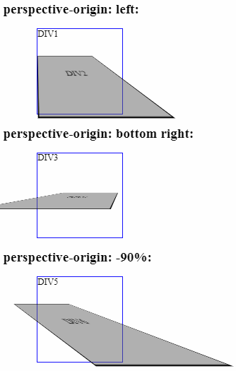<!DOCTYPE html>

<html>

<head>

<style>

#div1 {

position: relative;

height: 150px;

width: 150px;

margin-left: 60px;

border: 1px solid blue;

-webkit-perspective: 100px;

/\* Safari 4-8 \*/

-webkit-perspective-origin: left;

/\* Safari 4-8 \*/

perspective: 100px;

perspective-origin: left;

}

#div2,

#div4,

#div6 {

padding: 50px;

position: absolute;

border: 1px solid black;

background-color: red;

background: rgba(100, 100, 100, 0.5);

-webkit-transform-style: preserve-3d;

/\* Safari 3-8 \*/

-webkit-transform: rotateX(45deg);

/\* Safari 3-8 \*/

transform-style: preserve-3d;

transform: rotateX(45deg);

}

#div3 {

position: relative;

height: 150px;

width: 150px;

margin-left: 60px;

border: 1px solid blue;

-webkit-perspective: 100px;

/\* Safari 4-8 \*/

-webkit-perspective-origin: bottom right;

/\* Safari 4-8 \*/

perspective: 100px;

perspective-origin: bottom right;

}

#div5 {

position: relative;

height: 150px;

width: 150px;

margin-left: 60px;

border: 1px solid blue;

-webkit-perspective: 100px;

/\* Safari 4-8 \*/

-webkit-perspective-origin: -90%;

/\* Safari 4-8 \*/

perspective: 100px;

perspective-origin: -90%;

}

</style>

</head>

<body>

<h1>The perspective-origin Property</h1>

<h2>perspective-origin: left:</h2>

<div id="div1">DIV1

<div id="div2">DIV2</div>

</div>

<h2>perspective-origin: bottom right:</h2>

<div id="div3">DIV3

<div id="div4">DIV4</div>

</div>

<h2>perspective-origin: -90%:</h2>

<div id="div5">DIV5

<div id="div6">DIV6</div>

</div>

<p><strong>Note:</strong> The perspective-origin property is not supported in Internet Explorer 9 and earlier

versions.</p>

</body>

</html>